**Number Plate Detection**

**Hammad Ijaz**

This is the original image I took.

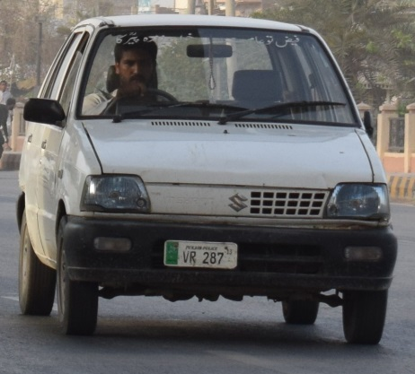

**Reading Image using CV2**

After reading the image, I changed the color of the image using the command ‘cv2.cvtcolor’ and then displayed the image using plt.imshow(). Since matplotlib expects image in RGB and our image was in BGR so I again applied another color conversion.

The result after changing the color to grey.

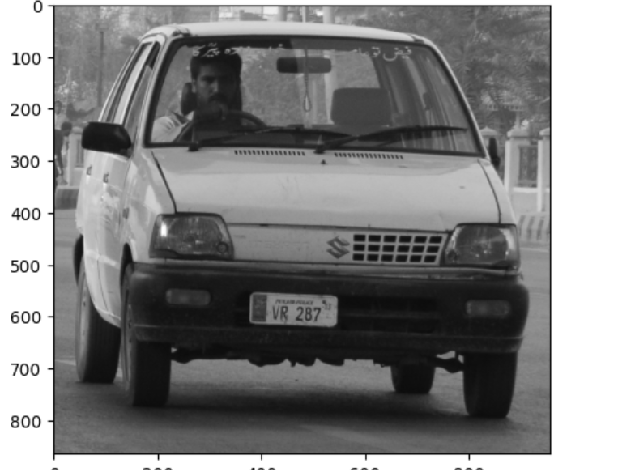

**Filtering and Edge Detection**

First I performed noise reduction and then used canny algorithm to help detect edges.

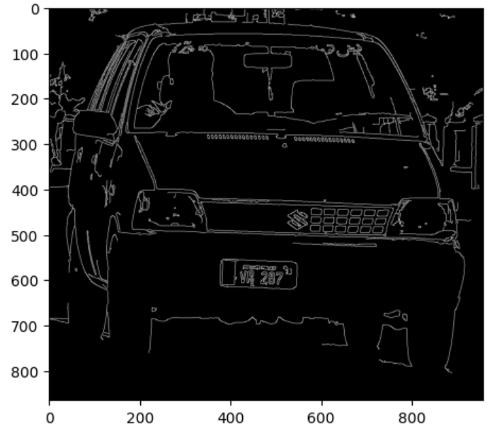

Now we can see some edges and contour around our number plate area. It helps tells us where our number plate actually is.

Now by using cv2.findcontour, it will detect the shape of the number plate. We gave two arguments on how to return the results. First argument is a tree which helps us to find different levels of contours. The second argument chain approx. simple helps us to return the type of the contour, allows us to get what contour looks like. Then we will look through all the contours until we get a square or a rectangle which basically represents a number plate.

After this I found out the coordinated of the number plate and then masked out the image to extract the number plate. I created a mask which created an image same as our imgae(copy). Mask will put a mask on all the region around the number plate and we will get only the number plate.

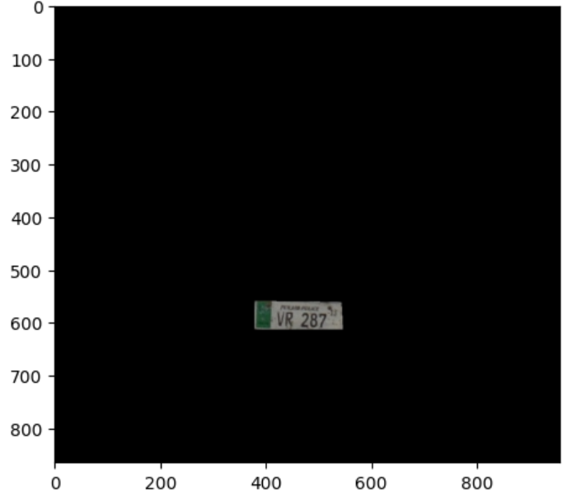

After this, I cropped the image to get only the number plate.

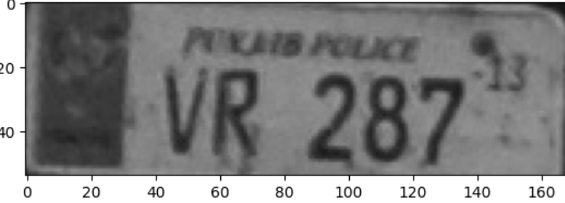

**OCR**

now by using the OCR, I got the text ‘VR 287’ along with the confidence.

